Multimodal Causal Decision Support ‐ Counterfactual Triage and Treatment Policies Under Constraints

Marisa Perera, Marco Ramirez, Samuel Feemster, Ashwith Jay, and Jonathan Malone
Georgia Institute of Technology
Atlanta, USA
{mperera3, marcoaramirez2003, sfeemster3, ajay37, jmalone42}@gatech.edu

Abstract—ICU resources are finite, forcing clinicians to make high-stakes triage decisions with incomplete information and under time pressure. Current clinical decision support tools rank patients by illness severity rather than expected benefit from ICU admission—failing to answer the most clinically relevant question: for this specific patient, does ICU admission reduce their probability of death? This paper presents a two-model clinical decision support system trained on the MIMIC-IV dataset that estimates both the severity and expected benefit of the patients in order to provide assistance in the use of the ICU's limited resources. A XGBoost architecture first determines the patient's severity in terms of their likelihood of requiring ICU admission, achieving an AUROC of 0.858 and a trifold improvement over the dataset's AUPRC from 0.197 to 0.655. Then, flagged patients pass through a T-Learner causal inference model that estimates the individual treatment effects of ICU admission on in-hospital mortality, in order to organize patients, prioritizing those that benefit most from admission. Furthermore, a fairness analysis demonstrated that excluding demographic features from model training and ensuring balanced classes produced more equitable performances and error distributions across demographic sub-cohorts. All causal estimates are observational and derived under the ignorability assumption; true individual treatment effects are not directly observed in EHR data.
Keywords—EHR Data, Causal Model, Predictive Model, XGBoost, Gradient Boost

BackGround and Motivation

Problem Statement
ICU bed availability is persistently limited, yet no systematic tool exists to estimate which patients will benefit most from admission. When patient demand exceeds available beds, clinicians must rapidly determine who benefits most from ICU-level care—under time pressure, with incomplete information, and no systematic tool for estimating treatment benefit. Existing triage approaches prioritize severity of illness, but severity and benefit are not equivalent: a critically ill patient may derive little benefit from ICU care, while a moderately ill patient may experience substantial mortality reduction through timely admission. Our system addresses this gap by jointly estimating ICU admission risk and individual causal treatment benefits, enabling prioritization of patients most likely to benefit under capacity constraints.

Background
Over five million patients are admitted to U.S. ICUs annually, yet bed availability remains persistently limited [1]. Hospital-acquired deterioration and delayed escalation to appropriate care remain leading causes of preventable in-hospital mortality. Existing clinical scoring systems such as APACHE and SOFA quantify illness severity but do not estimate individualized treatment effects. The result is a triage process that cannot systematically answer the most clinically relevant question: for this specific patient, does ICU admission reduce their risk of death? Answering this question requires counterfactual reasoning—estimating what would happen to a patient both with and without ICU admission—which is fundamentally a causal inference problem. This work addresses one of the five grand opportunities in AI for biomedical and health informatics: the development of AI-driven clinical decision support systems that improve healthcare delivery through individualized, data-driven recommendations [2].

Literature critique
Meta-learner frameworks for heterogeneous treatment effect estimation from observational data provide the methodological foundation for our causal component. Künzel et al. (2019) systematized the meta-learner framework including the S-Learner, T-Learner, and X-Learner, providing the methodological foundation for our causal component [3]. The T-Learner was selected over the S-Learner because it trains separate models per treatment group, capturing heterogeneous effects that a single model with treatment as a covariate may suppress. Shalit et al. (2017) introduced representation-based counterfactual regression (TARNet, CFRNet) [4], and Wager and Athey (2018) proposed causal forests for heterogeneous treatment effect estimation [5]—both demonstrate that individual-level causal inference is achievable on observational data under appropriate assumptions. What these works lack is integration with real-time clinical triage workflows, capacity constraints, or direct application to ICU admission decisions.
Gradient-boosted tree models have become the standard for tabular clinical prediction tasks due to their robustness to missingness and class imbalance. XGBoost has been widely validated for tabular clinical data [6]. Existing ICU risk scores are population-level tools that do not produce patient-specific benefit estimates. Our work extends this by using risk scoring as a filtering stage rather than a terminal output, passing flagged patients into a downstream causal ranking stage.
Commercial clinical algorithms have been shown to encode racial bias through the use of healthcare utilization as a proxy for health need [7], producing systematic underestimation of illness severity in disadvantaged groups. Their work motivates our deliberate exclusion of race, gender, insurance, and marital status from both models and our post-hoc fairness audit. The key limitation across all three bodies of literature is the absence of a unified system that jointly performs predictive risk scoring, causal ITE estimation, and fairness-aware feature selection for ICU triage—a gap our system directly addresses.

Methods

Data Methodology
We used the MIMIC IV Hosp and ICU modules [8] to form the base dataset for the predictive and causal model. Data included patient ids, demographic features, and lab values for tests that were run. Features were joined via the hadm_id and subject_ids. An ICU_Admit flag was created using the icustays module and corresponding patient ids. If a patient was recorded in that module, they were given a value of 1. If not, a value of 0 was assigned. This binary ICU_Admit flag serves as a key variable for the two models. For all lab values, we chose to take the last recorded value as it is the most representative of a decision prior to ICU admission. We also created lab_run columns to indicate if a test was run or not as it could serve as a key factor for decision making in our models. After performing a missingness analysis, if a subject was missing more than 90% of their values, they were removed from the dataset. The final dataset size was 179,533 non- ICU admissions and 43,919 ICU admissions. This was an imbalanced dataset of almost a 20-80 split which impacted model choices described later. In total, there were 163 factors: 4 demographic categories, 45 lab value columns, 53 diagnostic category columns, and additional hospital id information columns. The outcome variable is in-hospital mortality (hospital_expire_flag). The treatment variable is ICU admission, defined at the time of the last recorded lab value prior to the first ICU stay. The outcome window covers the full hospital admission. Patients with ICU stays recorded in icustays but who died prior to ICU transfer are excluded to avoid immortal-time bias.

Workflow Diagram
The project was divided into 4 main phases: data filtering, predictive model development and training, causal model development and training, and model validation and fairness analysis. The outline is detailed below in Figure 1.
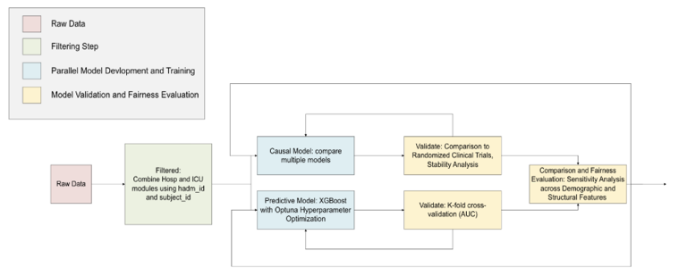
- Workflow diagram. (Details the project workflow’s main 4 phases: data filtering, predictive model development and training, causal model development and training, and model variation and fairness analysis)

Decision Making Methodology
Predictive Model
The implementation chosen for the predictive model, after careful consideration, was the XGBoost architecture due to its strengths in handling heterogeneous tabular data and its consistent performance in scenarios with high class imbalance disparities, such as the environment in which the developed model would have to operate. This choice was further solidified after continuing the literature search and confirming that such models are often used in clinical settings with high performance.
Having selected an architecture, training of the model with initial estimate hyperparameters was carried out to establish a baseline performance. The dataset was split such that only 70% of the data points were used for training, leaving the remaining 30% to be split across testing and validation equally. The validation strategy chosen was a fivefold cross-validation due to its continued use within the literature since it allows for confirmation of the model’s optimal performance and stability. After a baseline performance was established, threshold and hyperparameter optimization followed. First, threshold recall/precision analysis was performed through a grid search algorithm, allowing for the analysis of various metrics such as AUROC, F1 score, recall, and precision across different threshold values. Due to the nature of an ICU admission classifier, the inherent risk of missing patients with a lenient threshold is much higher than the increased system-wide strain of creating false alarms. Considering this and leveraging the results from the grid search algorithm, a value of 0.43 was found to be optimal for the decision threshold due to its reasonable tradeoff across precision and recall and the maintenance of an F1 score close to the maximum one observed with other threshold values. Having identified an optimal threshold, optimization of hyperparameters was carried out using Optuna’s Bayesian Optimization algorithm, chosen due to the largeness of the hyperparameter space. The results of that optimization run led to considerable changes across the initial estimates. The main changes were the decrease in the number of estimators from 408 to 297, showing that an earlier termination was beneficial. The maximum depth of each estimator being increased from 5 to 8, allowing the model to better capture feature importance. And the introduction of new hyperparameters, such as a minimum child weight with a value of 4 that ensures that no split is made if it has less than 4 patients for that leaf, and g with a value of 0.0096, which prevents splits from being made if they do not improve performance by at least the selected value.
As an overview, the predictive model’s decision-making methodology consists of a fivefold cross-validated XGBoost architecture with a stricter-than-average decision threshold and dataset-centered optimized hyperparameters, which allows for consistent and stable performance. This model serves as Stage 1 of a novel two-stage pipeline: its output—a flagged subset of patients at elevated ICU admission risk—feeds directly into the causal inference stage rather than serving as a terminal clinical output. This is detailed in Figure 2.
Causal Model
We employed the T-Learner meta-learner framework for Individual Treatment Effect (ITE) estimation. The T-Learner trains two separate outcome models: μ₁(x) for treated patients (ICU admitted) predicting P(death | ICU) and μ₀(x) for control patients (non-ICU) predicting P(death | no ICU). The ITE for a patient with features x is estimated as ITE(x) = μ₁(x) − μ₀(x). A negative ITE indicates that ICU admission reduces expected mortality for that patient. The Conditional Average Treatment Effect (CATE) refers to the expected ITE within a subgroup defined by features x. The Average Treatment Effect (ATE) is the mean ITE across all patients. PEHE (Precision in Estimating Heterogeneous Effects) measures the root mean squared error of estimated ITEs relative to true ITEs; however, because true individual treatment effects are never observed in real-world EHR data, PEHE here is approximated using a pseudo-outcome strategy via k=5 nearest-neighbor counterfactual matching on the held-out test set. This is a standard approximation in observational causal inference and should be interpreted accordingly, not as ground truth.
A key methodological assumption is ignorability: that all relevant confounders of ICU admission are captured in the observed features. This assumption is strong in this setting. ICU admission in MIMIC-IV is an observational decision made by clinicians in real time, based on factors including clinical judgment, family preferences, bed availability, and time-of-day effects that are not captured in structured EHR data. Even after overlap trimming, residual unmeasured confounding is likely. To address selection bias from clinician- driven admission decisions, we applied overlap trimming by estimating a logistic regression propensity score for each patient and removing those with propensity outside [0.1, 0.9]. This retains only patients for whom counterfactual inference is credible. A critical caution: even after trimming, residual unmeasured confounding may remain. The covariates used for propensity score estimation include all 163 features—lab values, lab_run indicators, and diagnostic categories—but exclude demographic features consistent with our fairness-aware design. Overlap trimming reduced the analysis population but improved covariate balance between treated and control groups, as confirmed by near-random post-trimming AUROC values across all seven base learners. The T-Learner ITE estimates should be interpreted as associational causal estimates under the ignorability assumption, not as experimentally established treatment effects.
Seven base learners were evaluated: Logistic Regression, Decision Tree, Random Forest, GradientBoost, SVC, K-Nearest Neighbors, and XGBoost. Each was trained on 60% of the trimmed data with 40% held out for evaluation, stratified by outcome. Models were evaluated on AUROC, F1, ATE Error, PEHE (Precision in Estimating Heterogeneous Effects), and treated/control subgroup accuracy. GradientBoost was selected based on lowest PEHE of 0.2131 and widest ITE heterogeneity, enabling the most meaningful patient differentiation for ranking. It is important to note that GradientBoost was not selected solely because it produced wider ITE heterogeneity. Wider heterogeneity is clinically necessary for a useful ranking: a model that assigns near-identical ITE scores to all patients provides no actionable differentiation under capacity constraints. SVC, while achieving the lowest PEHE (0.1675), assigned near-zero ITE variance across all patients, making it unsuitable for ranking. GradientBoost was selected as the best balance between causal precision (PEHE) and clinical utility (ITE heterogeneity sufficient for meaningful patient stratification). The ITE scores from this stage directly populate a ranked admission queue, translating counterfactual estimates into an actionable prioritization tool under real capacity constraints.

Results

Modeling Results
Predictive Model
To analyze the predictive model’s performance, several key features were identified and relied on to guide the design process throughout the training and testing cycles. Key metrics at baseline and final models are reported in the table below.
- Predictive model key metrics
Metrics | Baseline Model | Tuned
Validation Set Metrics

AUROC | 0.857 | 0.8581
AUPRC | 0.6513 | 0.6537
F1 Score | 0.5563 | 0.5628
Test Set Metrics

AUROC | 0.8586 | 0.8586
AUPRC | 0.6547 | 0.6559
F1 Score | 0.5574 | 0.5617
5-Fold Cross-Validation (Train+Val)

CV AUROC (mean ± std) | 0.8581 ± 0.0013 | 0.8581 ± 0.0014
CV AUPRC (mean ± std) | 0.6515 ± 0.0036 | 0.6540 ± 0.0036

Among the reported values, it is relevant to highlight the optimal performance of the model demonstrated by a consistent AUROC value of 0.85 across test, training, and validation runs, an AUPRC of 0.65 demonstrating a trifold increase to the dataset’s initial 0.197, and a maintained F1 score of 0.56, which remained close to the most optimal score obtained using other thresholds of 0.57. It must also be mentioned that the balance across precision and recall was achieved with the selected decision threshold of 0.43 where recall was 82.8% and precision 41.9%, meaning that the majority of patients requiring ICU are identified while risking only a small increase in the rate of false alarms compared to baseline.
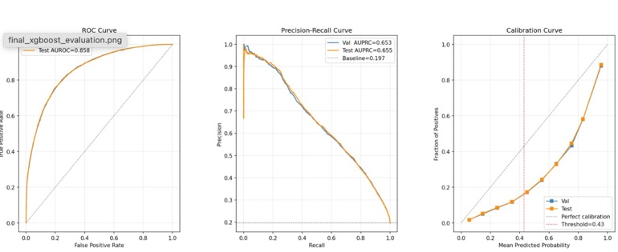
Fig 2. Predictive Model Results. (Graphs used to calculate AUROC and AUPRC and the calibration curve for validation and testing runs)
The figure above shows the graphs used to calculate the AUROC and AUPRC and the calibration curve for the validation and testing runs. From the latter, it can also be observed that the model is consistently overconfident, its curve lies under the perfect calibration diagonal, which translates to the model’s prediction predicting ICU admission more often than the actual probability for this occurring, this is done by design since it serves as a buffer for decreasing the high risk of missing a patient that requires admission at the cost of creating more, but less expensive, false alarms.
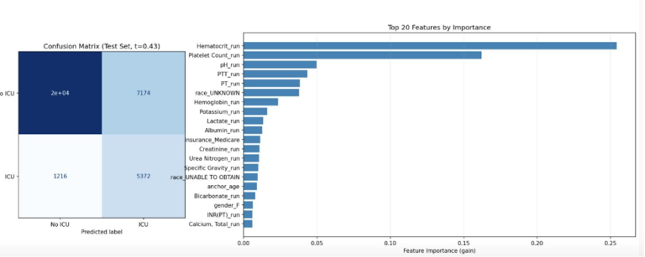

Fig. 3. Predictive Model Confusion Matrix and SHAP Values. (The confusion matrix highlights high accuracy in identifying non ICU admit cases with many false positive results. SHAP values include many test run markers and notably, include race)
Further evidence of this designed behavior can be observed in the confusion matrix, where there is an increased number of false alarms compared to the baseline but a significant improvement in the recognition of patients requiring ICU, leading to fewer unattended individuals that would have required intervention. To add transparency to the model, a SHAP feature analysis was carried out, where the twenty most relevant features and their importance were reported and are shown in the figure above.
However, as the SHAP values indicated race as an important feature of the predictive model, the model dataset was adjusted to remove demographic features of race, gender, insurance, and marital status and the model retrained. Subgroup fairness results from the predictive model show that after demographic feature removal, false positive and false negative rates are more equitably distributed across race, gender, and insurance subgroups.
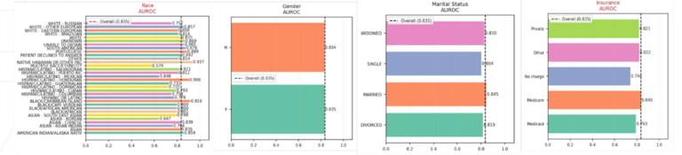
Fig. 4. Predictive Model Fairness Analysis. (Performed after manual removal of demographic features from the datase. The fairness analysis highlights improved distribution of false positive and false negative results)
In addition, the resulting confusion matrix was not significantly affected. However, there is a clear difference in the SHAP values that are deemed significant. With notably, the features of race no longer ranking in the top SHAP values.
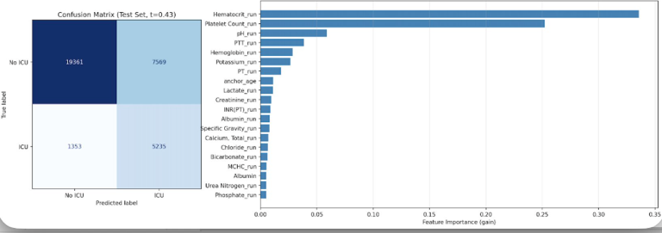
Fig. 5. Predictive Model Adjusted Results. (Retrained after manual removal of demographic features from the datase. The confusion matrix remains similar to before, but the top SHAP features notably no longer include race )
Following hyperparameter optimization, a heat map of sensitivity across the different hyperparameters was generated. From there, a plot comparing training and testing predictability was generated. Hyperparameter choices correspond to plateau of testing performance indicating no further need for increasing the model’s complexity to improve its performance.
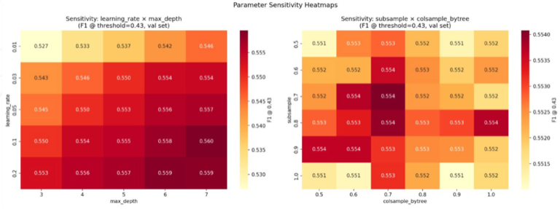
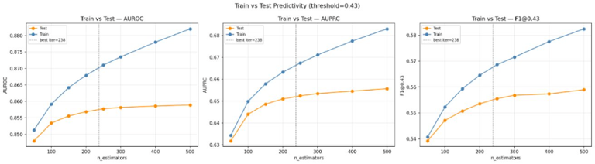
Fig. 6. Predictive Model Plots of Sensitivity and Predictability. (Parameters were selected during the Optuna Hyperparameter Optimization stage)

Causal Model
After overlap trimming, all seven T-Learner variants show AUROC ≈ 0.50 (range: 0.489–0.506), which is expected and desirable—it confirms the trimmed population is well-balanced and selection bias has been reduced. Near-random AUROC after trimming is a positive diagnostic: it indicates that treated and control patients in the trimmed population are no longer easily separable by features alone, which is the condition required for credible counterfactual inference. It does not indicate model failure. F1 scores are near zero across all models (best: 0.045 for LogReg and DecisionTree; SVC and KNN at 0.000). Near-zero F1 scores are also expected in this setting. After overlap trimming, the remaining population is near-balanced in terms of propensity, but in-hospital mortality remains rare (~2–3%). Models trained to estimate potential outcomes rather than predict a binary label will not optimize for F1, which is a classification metric. PEHE and ATE Error are the appropriate causal evaluation metrics here. PEHE ranges from 0.1675 (SVC) to 0.3120 (XGBoost). GradientBoost (PEHE = 0.2131) was selected despite not having the lowest PEHE because it produces the widest ITE heterogeneity, enabling meaningful patient stratification.

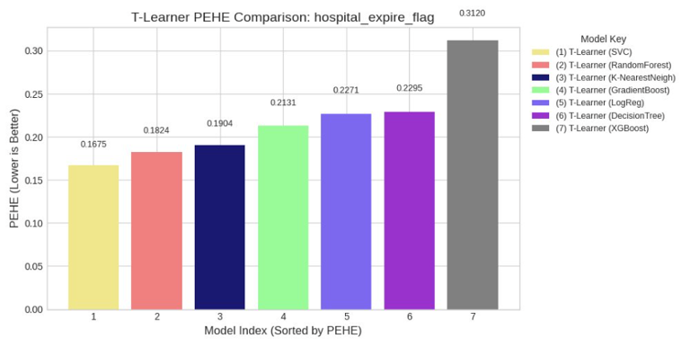
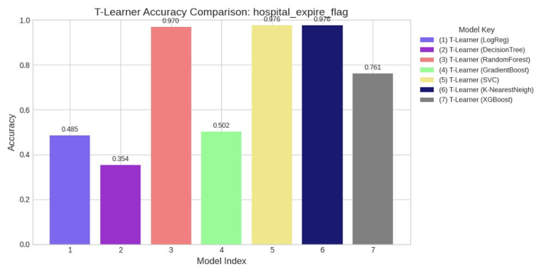
Fig. 7. Causal Model Selection. (PEHE across seven T learner base madels and corresponding accuracy scores. Gradient Boost was chosen due to having the wides ITE heterogeneity)
The estimated Average Treatment Effect (ATE) of ICU admission on in-hospital mortality is −3.49 percentage points (95% CI: −3.63, −3.34), indicating a meaningful mortality reduction on average. This ATE is an observational estimate under the ignorability assumption and should not be interpreted as a randomized or experimentally established causal effect. However, this average masks substantial heterogeneity across individual patients, which is precisely what the ITE ranking captures.
ITE distribution analysis reveals that the majority of patients fall in the benefit zone (ITE < 0, blue zone), with a meaningful subset in the potential harm zone (ITE > 0, red zone). Mean ITE = −0.055 across the full test population. The four benefit tiers are:
- High Benefit (ITE ≤ −0.10): mean ITE = −0.216 — prioritize first
- Moderate Benefit (−0.10 < ITE ≤ −0.022): mean ITE = −0.054
- Low Benefit (−0.022 < ITE ≤ 0): mean ITE = −0.016
- Potential Harm (ITE > 0): mean ITE = +0.068 — deprioritize
Under real ICU capacity constraints, clinicians should use ITE rankings as one input among several rather than as a deterministic admission decision. Patients in the High Benefit tier should be prioritized for available beds. Patients in the Potential Harm tier should not be automatically excluded from ICU consideration—clinical judgment, patient preferences, and factors not captured in the model must always be incorporated. The ranking is intended to flag and organize, not to replace clinical decision-making.
Overlap diagnostics confirm that propensity trimming at [0.1, 0.9] removed extreme confounding cases and produced a well-supported common support region. Treatment effect by propensity quartile shows Q3 patients (high ICU propensity) experience the strongest benefit (mean CATE ≈ −15pp) while Q1 patients (low propensity) show marginal harm (+5pp), consistent with clinical intuition that patients already predisposed to ICU admission benefit most.
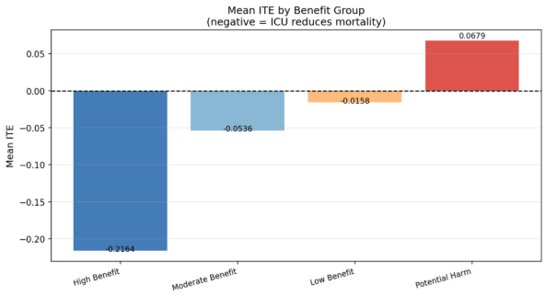
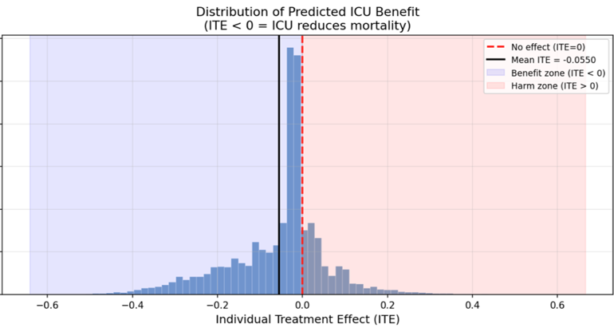
Fig. 8. Causal Model Results. (Top: Distribution of predicted ITE acress patients with the majority falling in the benefit zone. Bottom: Mean ITE by subgroup)
Sensitivity analysis across 27 GradientBoost hyperparameter configurations (n_estimators ∈ {50,100,200}, max_depth ∈ {3,5,7}, learning_rate ∈ {0.05,0.1,0.2}) shows PEHE range of 0.014 (0.221–0.238), confirming stable causal estimates that are not highly sensitive to hyperparameter choice. Age distribution across ITE benefit tiers is nearly identical, confirming the causal model ranks on clinical signal rather than demographic characteristics.
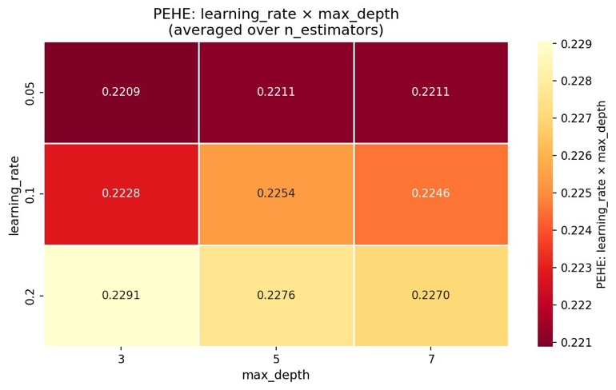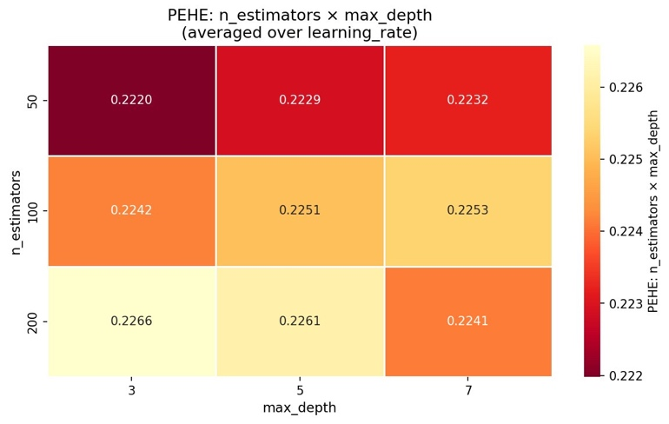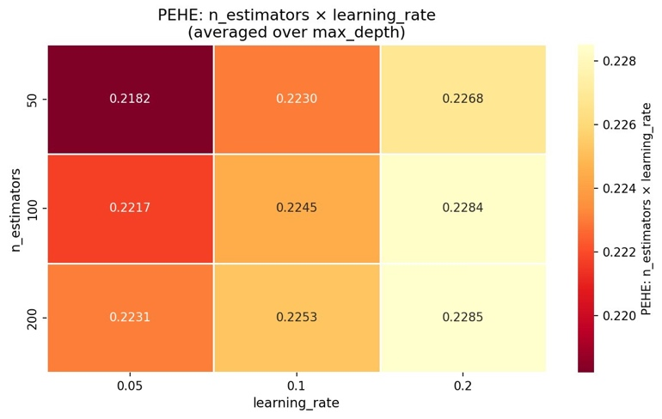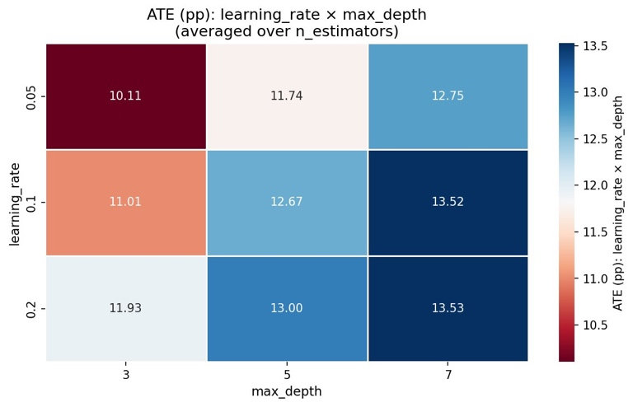
Fig. 9. Causal Model Sensitivity Analysis (Comparison of sensitivity across the various hyperparameters)

Discussion
The implemented model presents two components to aid in the clinical decisions of ICU admission by addressing the gaps in the current ICU triage methodology, such as the absence of a data-driven framework for prioritizing patients under capacity constraints. Rather than relying on a single severity score, the system combines a predictive risk scoring stage with a causal inference stage, which together provide a suggested guideline to prioritize patients given the finite ICU resources.
The predictive model’s performance had strong conventional metrics, yet it is best understood in the context of the clinical tradeoffs that it was designed around. For instance, the calibration of the decision threshold in favor of a higher recall and lower precision is a key design choice that serves as a safety measure to reduce the risk of missing patients who require ICU admission. The fairness analysis further revealed that certain demographic factors may influence the decision of the model and were therefore removed from the training dataset to reduce bias, showing that it was possible to approximate a demographics-agnostic model. However, removing demographic features alone does not fully eliminate bias. Proxy bias may persist through features that are correlated with demographics—for example, certain lab values, diagnostic categories, or insurance-linked care patterns may encode demographic information indirectly. Subgroup-level evaluation of precision, recall, false negative rate, and false positive rate across race, gender, and insurance subgroups was performed and showed improved distributional equity after demographic feature removal, but residual proxy bias cannot be fully ruled out. Fully bias-free prediction in observational clinical data remains an open problem. In general, the predictive model’s role within the system is not to take a final decision but to accurately, transparently and equitably reduce the patient population to those requiring deeper evaluation.
This system demonstrates that combining predictive risk scoring with counterfactual ITE estimation produces a clinically meaningful ICU triage tool. The key insight is that ranking patients by ITE—rather than by severity or predicted risk—answers the correct clinical question: not who is sickest, but who benefits most from ICU admission. The ATE of −3.49pp is an observationally estimated, statistically significant, and clinically meaningful treatment effect and the ITE distribution reveals substantial treatment effect heterogeneity that a single population-level score would obscure.
Several causal assumptions warrant explicit discussion. The T-Learner assumes ignorability—no unmeasured confounders—which cannot be verified from observational data. ICU admission decisions in MIMIC-IV were made by clinicians responding to real-time patient status, introducing selection bias that overlap trimming only partially addresses. Additional potential biases include: (1) immortal-time bias, partially mitigated by excluding patients who died prior to ICU transfer; (2) indication bias, where sicker patients are more likely to be admitted to the ICU and also more likely to die, confounding the treatment-outcome relationship; and (3) documentation bias, where the completeness of lab values may differ systematically between ICU and non-ICU patients. The near-random AUROC values after trimming are evidence of successful deconfounding but do not guarantee unbiased ITE estimates. Future work should apply doubly robust estimators or instrumental variable methods to further address this limitation. Causal conclusions should therefore be interpreted as estimates under the ignorability assumption, not as experimentally established effects. Clinical notes, imaging, and provider-level variables were not incorporated in this analysis and represent an important direction for future multimodal work.

Novelty
The primary novelty of this work lies in the integration of three components not previously combined in a unified ICU triage system: (1) a fairness-aware XGBoost predictive model with Optuna-tuned hyperparameters and threshold optimization, (2) a T-Learner causal ITE framework with propensity-based overlap trimming and sensitivity analysis across 27 configurations, and (3) a patient ranking mechanism that directly links ITE estimates to a prioritized admission queue under capacity constraints—translating counterfactual estimates into an actionable clinical tool. Existing clinical tools either score severity or predict outcomes; none provide individualized counterfactual benefit estimates for triage ranking.

Mock Up GUI
A mockup of a proposed interface of our models is shown below. The dashboard presents clinicians with a ranked patient list sorted by ITE score, displaying each patient's predicted ICU risk (from the predictive model), estimated ITE (from the causal model), and benefit tier classification. Under constrained capacity, clinicians work down the ranked list from highest benefit to lowest, with Potential Harm patients flagged for review.
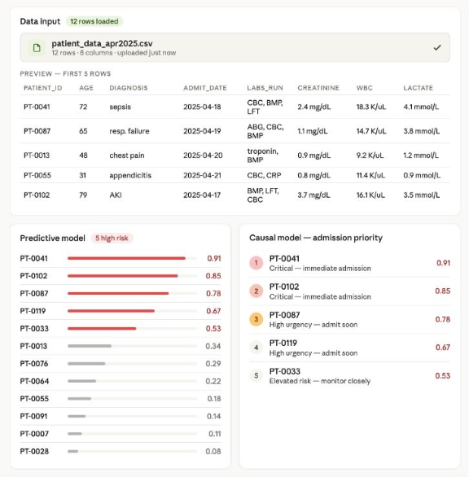

Fig. 10. Mock Up GUI (Shows both predictive model risk scores and causal model ranking to portray clear actions needed for ICU prioritization)

Conclusion
This work presents a dual-model clinical decision support system for ICU triage that combines XGBoost risk scoring (AUROC 0.858) with T-Learner GradientBoost causal ITE estimation (PEHE 0.2131, ATE = −3.49pp) to rank patients by individualized treatment benefit. Key findings include: overlap trimming successfully reduces selection bias, producing well-balanced treated and control groups; GradientBoost provides the most actionable ITE heterogeneity for patient ranking despite not achieving the lowest aggregate PEHE; fairness-aware feature exclusion meaningfully reduces demographic disparity in both model components; and the ITE distribution reveals that while most patients benefit from ICU admission on average, a meaningful subset shows potential harm, underscoring the clinical value of individual-level causal reasoning over population averages.
Limitations include retrospective single-institution data, the strong ignorability assumption in an observational setting where clinician admission decisions introduce unmeasured confounding, residual class imbalance, residual proxy bias after demographic feature removal, and the absence of prospective clinical validation. PEHE values are approximated via pseudo-outcome matching and should not be interpreted as ground-truth individual treatment effect error. Future work includes prospective validation in live hospital settings, integration with real-time EHR systems, incorporation of clinical notes and multimodal data sources, application of doubly robust causal estimators, decision-curve analysis to assess net clinical benefit of the ITE ranking, and extension to additional scarce resource allocation problems such as ventilator and operating room scheduling.

Acknowledgment
We would like to thank our TA Nishant Chouhan and our Professor May Dongmei Wang for their continued support during this project.

References
- Halpern, N. A., & Pastores, S. M. (2010). Critical care medicine in the United States2000-2005: an analysis of bed numbers, occupancy rates, payer mix, and costs. Critical care medicine, 38(1), 65–71. https://doi.org/10.1097/CCM.0b013e3181b090d0
- Shortliffe, E. H., & Sepúlveda, M. J. (2018). Clinical Decision Support in the Era of Artificial Intelligence. JAMA, 320(21), 2199–2200. https://doi.org/10.1001/jama.2018.17163
- Künzel, S. R., Sekhon, J. S., Bickel, P. J., & Yu, B. (2019). Metalearners for estimatingheterogeneous treatment effects using machine learning. Proceedings of the National Academy of Sciences, 116(10), 4156–4165. https://doi.org/doi:10.1073/pnas.1804597116
- Shalit, U., Johansson, F. D., & Sontag, D. (2017). Estimating individual treatment effect: generalization bounds and algorithms Proceedings of the 34th International Conference on Machine Learning, Proceedings of Machine Learning Research. https://proceedings.mlr.press/v70/shalit17a.html
- Wager, S., & Athey, S. (2018). Estimation and Inference of Heterogeneous Treatment Effects using Random Forests. Journal of the American Statistical Association, 113(523),1228–1242. https://doi.org/10.1080/01621459.2017.1319839
- Chen, T., & Guestrin, C. (2016). XGBoost: A Scalable Tree Boosting System Proceedings of the 22nd ACM SIGKDD International Conference on Knowledge Discovery and DataMining, San Francisco, California, USA. https://doi.org/10.1145/2939672.2939785
- Obermeyer, Z., Powers, B., Vogeli, C., & Mullainathan, S. (2019). Dissecting racial bias in an algorithm used to manage the health of populations. Science, 366(6464), 447–453. https://doi.org/doi:10.1126/science.aax2342
- Johnson, A. E. W., Bulgarelli, L., Shen, L., Gayles, A., Shammout, A., Horng, S., Pollard,T. J., Hao, S., Moody, B., Gow, B., Lehman, L.-w. H., Celi, L. A., & Mark, R. G. (2023). MIMIC-IV, a freely accessible electronic health record dataset. Scientific Data, 10(1), 1.https://doi.org/10.1038/s41597-022-01899-x

Appendix
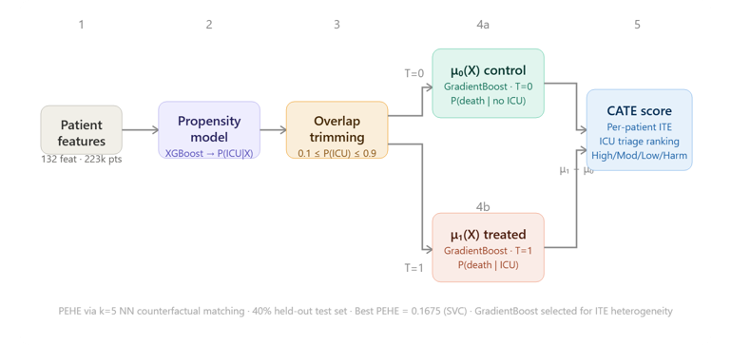
Fig. 11 Causal Model Workflow (Utilizes overlap trimming to improve result)

Fig. 12 Predictive Model Workflow (se of XGBoost with Optuna Hyperparameter Optimization followed by a fairness analysis across demographic subcohorts)

